Learning Mentor (Grade 5)
35 hours per week (term time only)
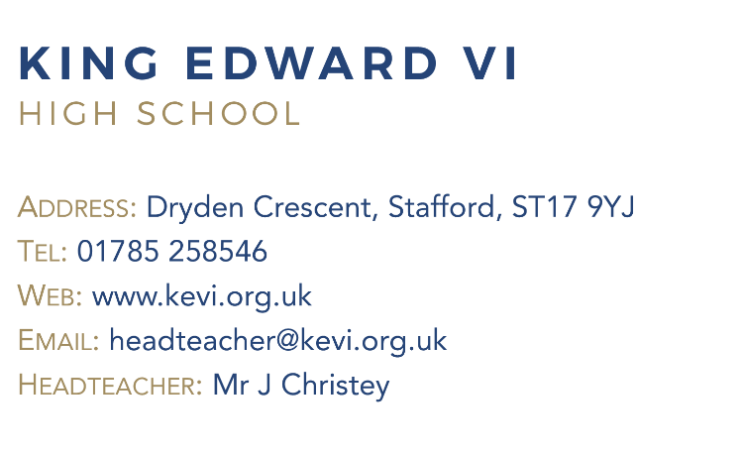
Governors are looking for an energetic, adaptable and committed individual to work with our learners. The successful candidate will work to support all students across the school. The post will ensure support is put in place to enable all students to access learning, with particular focus on students on the SEN, EAL and ASD registers.
The role is a varied one and you will be:
- providing one to one and in-class support for key vulnerable students as identified
- working with students providing withdrawal support for individuals and, on occasions, small groups of students of any ability and in any curriculum area
- supervising and provide particular support for students, including those with special needs and who have EAL, ensuring their safety and access to learning activities
- working with students and teachers to facilitate their re-introduction to lessons
- working with students on intervention programmes both inside and outside of the classroom
- To promote the inclusion and acceptance of all students, encouraging them to interact with others but also act independently where appropriate
- To assist in the overall raising of standards for students with SEN, ASD and EAL through raising students’ self-esteem, expectations and aspirations

An ability to support students with basic skills in English and Maths will be an advantage, as will good ICT skills. Strong organisation skills, the ability to inspire students and a positive outlook are essential.
Please email applications@kevi.org.uk for an application pack.
Closing date: Monday 13th February 2023 at 9.00 am
King Edward VI High School is committed to safeguarding and promoting the welfare of children and expect all staff and to share this commitment.
The successful candidate will be subject to all necessary pre-employment checks, including: an enhanced DBS; Prohibition check; qualifications medical fitness; identity and right to work. All applicants will be required to provide two suitable references.
An online search will also be carried out as part of due diligence on all short-listed candidates.

