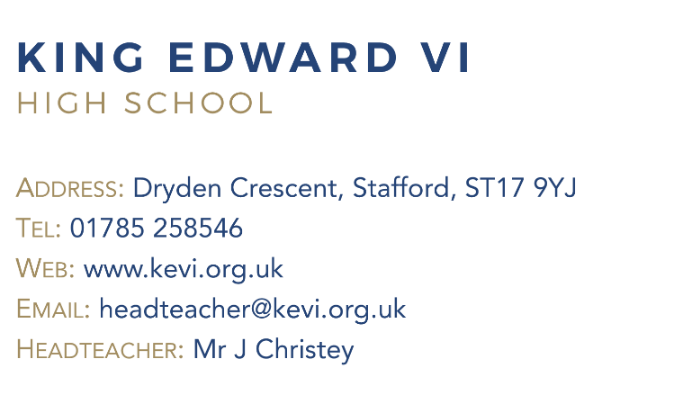
At King Edward VI High School each individual is inspired and supported to achieve their potential and “Be the best they can be”.

The school is a place where

“Teachers know their pupils well and pupils trust their teachers and other adults. Consequently, they feel safe. Pupils behave well in lessons and at other times of the day. They are polite, articulate and friendly” - Ofsted 2018

King Edward VI High School is part of the Walton Multi Academy Trust and is a mixed, fully comprehensive, 11 – 18 High school with over 600 pupils.

The intake is derived from a catchment area that provides a genuine comprehensive mix of social groups from urban to rural areas. The school is situated on the outskirts of the West side of Stafford just 10 minutes from junction 13 and 14 of the M6, taking students from both Stafford Town and the rural areas to the West, right up to the Shropshire border. There are four other secondary schools in Stafford who have a close working relationship, particularly in relation to the Sixth Form Partnership, where all five Stafford High Schools collaborate to offer a range of A Level courses.

Beyond School achievement, King Edward VI High School not only offers academic challenge and support but also places great emphasis on the personal development and wellbeing of all students. There is an abundance of enrichment activities supported by teaching and non-teaching staff.

As the school moves from strength to strength this is an exciting time to join a vibrant, happy and forward-facing community.

