Withdrawal Room Supervisor (Grade 5)
35 hours per week (term time only)
Fixed Term Contract
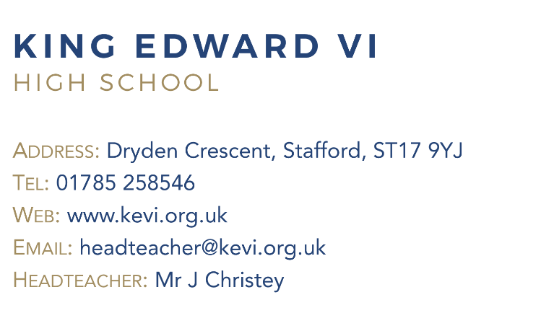
Governors are looking for an energetic, adaptable and committed individual to work with our learners. The successful candidate will work to support all students and staff across the school and may have experience in working in a secondary school environment.
The role is a varied one and you will be:
- Work with students who are removed from timetabled classes
- Send for appropriate work and supervise completion
- Working with students and teachers to facilitate their re-introduction to lessons
- To promote the inclusion and acceptance of all students, encouraging them to interact with others but also act independently where appropriate
Strong organisation skills, the ability to inspire students and a positive outlook are essential.
Applications packs are available from Ms Coughlan, Bursar. (email applications@kevi.org.uk)

Closing date: Monday 13th February 2023 at 9.00 am

King Edward VI High School is committed to safeguarding and promoting the welfare of children and expect all staff and to share this commitment.
The successful candidate will be subject to all necessary pre-employment checks, including: an enhanced DBS; Prohibition check; qualifications medical fitness; identity and right to work. All applicants will be required to provide two suitable references.
An online search will also be carried out as part of due diligence on all short-listed candidates.

